ServiceConnect
Project Proposal Report & ER Diagram

Description (1-2 short paragraphs) [10]
ServiceConnect: On-Demand Service Worker Platform
ServiceConnect is a database-driven marketplace application built with .NET framework and SQL Server that directly connects service workers (cleaners, plumbers, electricians, maintenance personnel) with customers needing on-demand services. The platform enables workers to register, verify their skills, and set availability schedules while customers can post detailed job requirements with specific budgets and timelines.
The system implements dual Business Logic Layer approaches using both LINQ queries and stored procedures, dynamically switchable through the Factory Design Pattern. Core functionality includes worker profile management, job posting with categorization, competitive bidding system, booking management, and a comprehensive dual-sided rating mechanism to ensure service quality and accountability.

Problem Statement and Motivation (1-2 paragraphs) [20]
The current service worker market suffers from severe inefficiencies where customers struggle to find reliable, verified workers quickly, often relying on unreliable word-of-mouth recommendations or expensive agencies that charge 30-40% commissions. Simultaneously, skilled workers lack a centralized platform to showcase their expertise and find consistent work opportunities, leading to income instability and underutilization of their skills. This disconnection results in longer wait times for customers, higher service costs, and reduced earning potential for workers.
ServiceConnect addresses these pain points by creating a direct, transparent marketplace that eliminates intermediaries. The platform reduces service costs by enabling competitive bidding, ensures worker quality through background check tracking and verified ratings, provides workers with steady job opportunities based on their skills and availability, and creates accountability through a comprehensive review system. This solution benefits both parties - customers get faster, cheaper, more reliable services while workers gain increased visibility, flexible scheduling, and better income opportunities without agency fees.

Key objectives of your system and how you plan to achieve them (bullet points) [30]
- Enable efficient worker-customer matching
  - Implement skill-based categorization system linking workers to relevant job postings
  - Create location-based filtering using latitude/longitude coordinates for proximity matching
  - Design availability management system to prevent scheduling conflicts
- Establish transparent pricing through competitive bidding
  - Develop real-time bidding engine allowing multiple workers to submit proposals
  - Implement bid ranking algorithms using stored procedures for fair evaluation
  - Create bid expiration and acceptance workflows with automatic status updates
- Ensure service quality and accountability
  - Build comprehensive review system with dual-sided ratings (customer-worker, worker-customer)
  - Track background check status and certification expiry dates for worker verification
  - Calculate and display performance metrics through aggregate rating views
- Optimize database performance for scalability
  - Implement table partitioning on Jobs and Bookings tables by date ranges
  - Create clustered and non-clustered indexes on frequently queried columns
  - Use stored procedures for complex operations like booking creation and status transitions
- Provide flexible data access patterns
  - Implement Factory Pattern to switch between LINQ and stored procedure approaches
  - Create views for complex reporting and performance summaries
  - Design triggers for automatic notifications and cascading updates

Outline the system's main features, operations, and outcomes (choose top 3-5) [20]
- Worker Profile and Skill Management System
  - Operations: Registration, skill verification upload, certification tracking, availability scheduling
  - Outcomes: Verified worker database with searchable skills, automated certification expiry alerts, real-time availability checking
- Job Posting and Bidding Engine
  - Operations: Categorized job creation, attachment uploads, bid submission, automatic bid ranking
  - Outcomes: Transparent marketplace with competitive pricing, reduced time-to-hire, fair opportunity distribution
- Booking and Scheduling Management
  - Operations: Bid acceptance, calendar conflict detection, booking confirmation, status tracking
  - Outcomes: Automated scheduling coordination, reduced no-shows through booking codes, completion tracking
- Comprehensive Rating and Review System
  - Operations: Post-service reviews, rating aggregation, dispute flagging, performance calculation
  - Outcomes: Quality assurance through accountability, trustworthy worker rankings, customer satisfaction metrics
- Real-time Notification System
  - Operations: Trigger-based notifications for bids/bookings/reviews, status change alerts, read tracking
  - Outcomes: Improved response times, reduced missed opportunities, enhanced user engagement

ER DIAGRAM
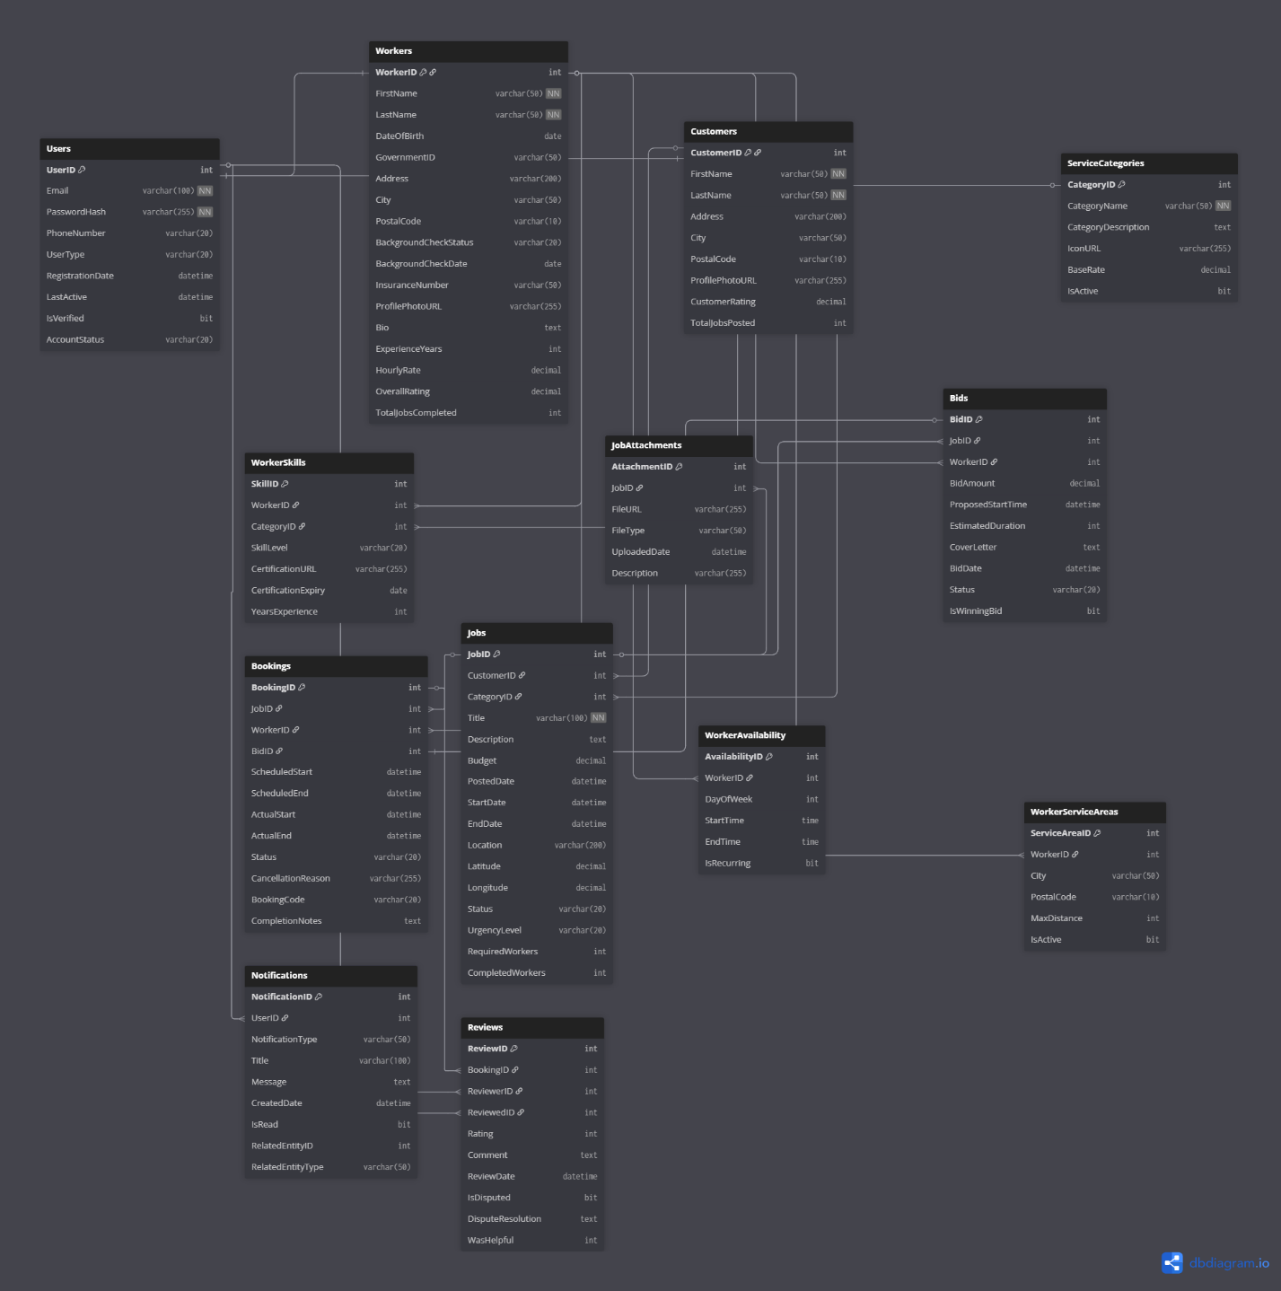

Names | Roll numbers
Baqir Hassan | 27100340

